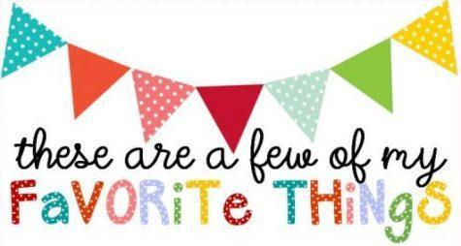

ALL ABOUT: Andrea Jingco (Mrs. J)

Birthday: September 24

Favorite Flower/Plant: Plumeria

Favorite Restaurant: Cracker Barrel, Mooyah, Old Town Pizza, Bud's Burgers...

Favorite Candy/Treats: Lime Skittles, Reese's Mini butter cups, and Peanut M&Ms

Favorite Scents: Apple

Favorite Afternoon pick me up: Chocolate, Cookies, or Ice cold Coke

Favorite Bookstores: Amazon and Apple

Favorite actual Stores: Daiso, Sephora, ULTA, and Hobby Lobby

Favorite Drinks: Chick-fil-A Frosted Lemonade, Avocado Smoothies with boba, Caramel Frappuccinos, and Ice cold Coke

Favorite Holiday: Christmas and July 4th

Favorite Season: Autumn

Favorite Sports Team: SF Niners, SF Giants, Detroit Tigers

Hobbies:Watching Baseball games live or on TV with my family, Crafting, and Drawing

